D.A.V. Public School
Khera Khurd / Budhpur
Holidays Home Work (2017 – 2018)
Class – II
Dear children,

Enjoy yourself during this winter break, have loads of fun. Make the beginning of the year fruitful and enjoyable. Kindly complete the given homework during your winter break.

English:

- Search any ten past forms from the newspaper and paste it in the activity file.

- Learn story written in your wards school diary for story narration.

Math:

- Make a smiley face with whole, half and quarter. (in activity file)

- Revise tables from 2 to 9.

EVS:

- Make a collage land, water & air transport in activity file.

- Paste pictures of things used in rainy, summer & winter season in activity file.
Hindi:
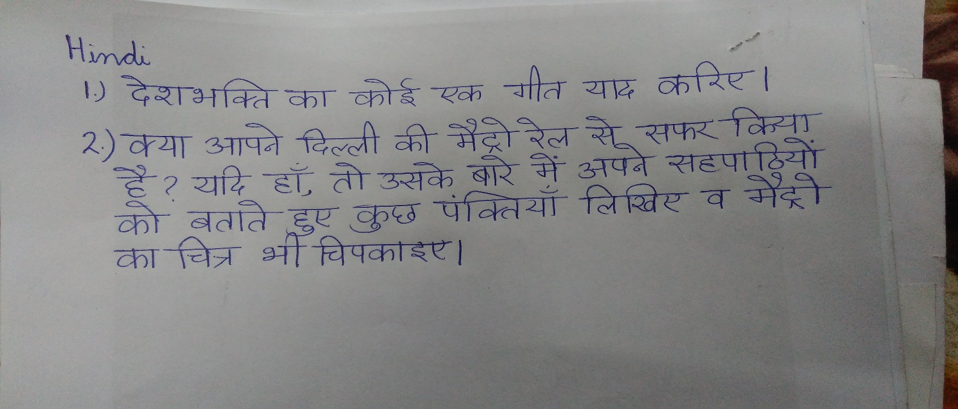

Art & Craft:

- Make any two scenes of your choice on A4 size pastel sheet.

